**NOTE: This is an official document by Indexademics. Unless otherwise stated, this document may not be accredited to individuals or groups other than the club IDX, nor should this document be distributed, sold, or modified for personal use in any way.**

**IDX G9 MATH S+ STUDY GUIDE ISSUE 5**

**By Aiden Zhan and Julie Zhu**

**Contents:**

1. ***8-1 The Pythagorean Theorem and Its Converse***
2. ***8-2 Special Right Triangles***
3. ***8-3 The Tangent Ratio***
4. ***8-4 Sine and Cosine Ratios***
5. ***8-5 Angles of Elevation and Depression***
6. ***Solving right triangle***
7. ***The area of a triangle***
8. ***Area of Parallelograms***
9. ***Area of trapezoids, rhombuses & kites***
10. ***Area of regular polygons***
11. ***Perimeters of regular polygons***
12. ***Trigonometry and areas***
13. ***8-1 The Pythagorean Theorem and Its Converse***

**1-New Theorem**

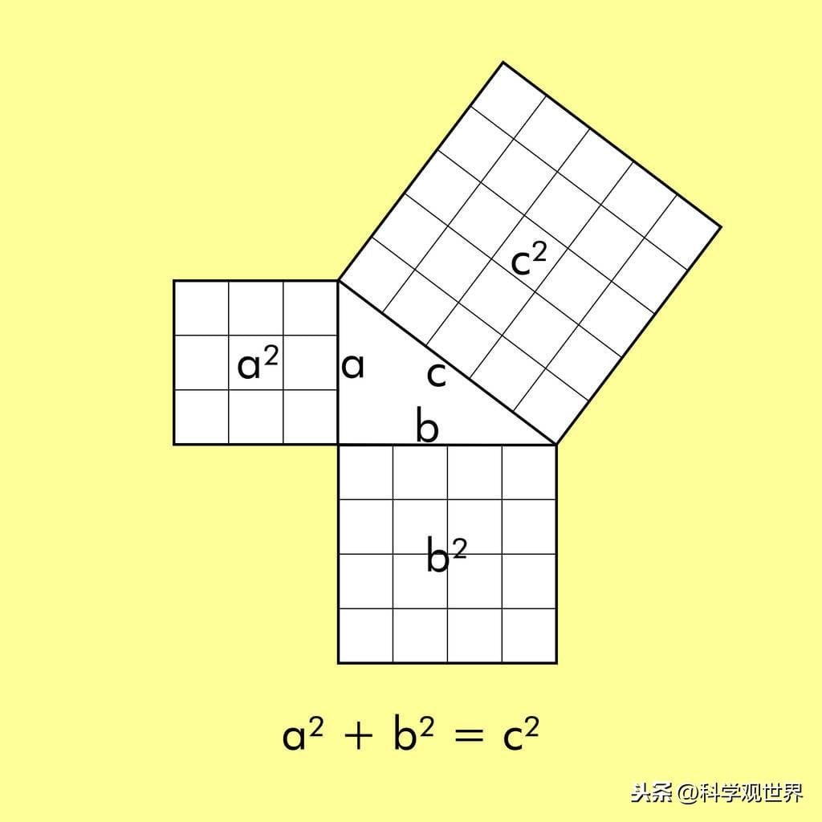**·Th 8-1(Pythagorean Theorem) In a right triangle, the sum of the squares of the lengths of the legs is equal to the square of the length of the hypotenuse. Just a²+b²=c²。**

**·Th 8-2(Converse of the Pythagorean Theorem) If the square of the length of**

**one side of a triangle is equal to the sum of the squares of the lengths of the other**

**two sides, just a²+b²=c², then the triangle is a right triangle.**

**·Th 8-3 If the square of the length of one side of triangle is greater than the**

**sum of the squares of the lengths of the other two sides, just a²+b²<c²,then the**

**triangle is a obtuse triangle.**

**·Th 8-4 If the square of the length of one side of a triangle is smaller than the sum of the squares of the length of the other two sides, just a²+b²>c², then the triangle is acute triangle.**

**2-New terms**

**·*Pythagorean triple***

**Pythagorean triple is a set of nonzero three numbers a,b,c that satisfy a²+b²=c².**

**Examples of Pythagorean triple:**

1. **a=3 ,b=4 ,c=5**
2. **a=5 ,b=12 ,c=13**
3. **a=8 ,b=15, c=17**
4. **a=7 ,b=24, c=25**
5. **a=9 ,b=40, c=41**
6. **a=11 ,b=60, c=61**
7. **a=12 ,b=35, c=37**
8. **a=13 ,b=84, c=85**

**(better to memorize)**

1. ***8-2 Special Right Triangles***
2. **New Theorem**

**·Th 8-5 (45°-45°-90°Triangle Th) In a 45°-45°-90°triangle, both legs are congruent and the length of the hypotenuse is times the length of a leg. Just 3 sides are in ratio 1:1:.**

**·Th 8-6 (30°-60°-90° Triangle Th) In a 30°-60°-90°triangle, the length of the**

**hypotenuse is twice the length of the shorter leg. The length of longer leg is times the length of the shorter leg. Just 3 sides are in ratio 1:2:**

1. ***8-3 The Tangent Ratio***
2. **New terms**

**·*Adjacent leg***

***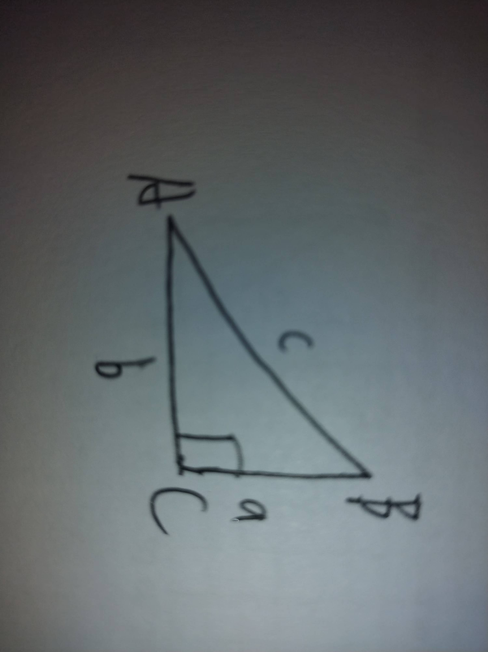*Adjacent legs refer to the two sides of a right triangle that are connected to the right angle. Just a and b on the right picture.**

**·*Opposite leg***

**Opposite legs refers to the side of the triangle that is across from a given acute angle. Just a is the opposite leg of angle A on the right picture.**

**·*Tangent ratio***

**Tangent ratio is defined as the ratio of the length of the opposite side to the length of the adjacent side relative to a given acute angle in a right triangle. For example, the tangent ratio of the angle A in the right picture is equals to ratio of a to b. BUT, it depends on the measure of the angle rather than the size of the sides.**

**Plus, with the tangent ratio of one angle, we can find the length of its opposite side by tangent ratio*hypotenuse and find the length of its adjacent side by hypotenuse/tangent ratio. Just a=tan(m∠a)*c, b=in the right picture.**

1. **New symbols**

**·*tan***

***tan* is defined as the symbol to find tangent ratio of one angle by the measure of that angle. For example, *tan*(30°)=0.577**

**·**

**is defined as the symbol to find the measure of one angle by tangent ratio of that angle which is also the converse version of *tan*. For example, 0.577)=30°**

**Plus, for that *tan* and are the converse version of each other, noting will happen to the value if you *tan* it and then it. For example, (tan(30°))=30°**

1. ***8-4 Sine and Cosine Ratios***
2. **New terms**

**·*Sine ratio***

 Sine ratio is defined as the ratio of the length of the opposite side to the length of the hypotenuse relative to a given acute angle in a right triangle. For example, the sine**

**ratio of the angle A in the right picture is equals to ratio of a to c.**

**·*Cosine ratio***

**Cosine ratio is defined as the ratio of the length of the adjacent side to the length of the hypotenuse relative to a given acute angle in a right triangle. For example, the sine**

**ratio of the angle A in the right picture is equals to ratio of b to c.**

1. **New symbols**

**·*sin***

***sin* is defined as the symbol to find sine ratio of one angle by the measure of that angle. For example, *sin*(30°)=0.5**

**·*cos***

***cos* is defined as the symbol to find cosine ratio of one angle by the measure of that angle. For example, *cos*(30°)=0.866**

**·**

**is defined as the symbol to find the measure of one angle by sine ratio of that angle which is also the converse version of *sin*. For example, 0.5)=30°**

**·**

**is defined as the symbol to find the measure of one angle by cosine ratio of that angle which is also the converse version of *cos*. For example, 0.866)=30°**

1. **Others**

**The others which is mentioned in that chapter are included in this picture.**

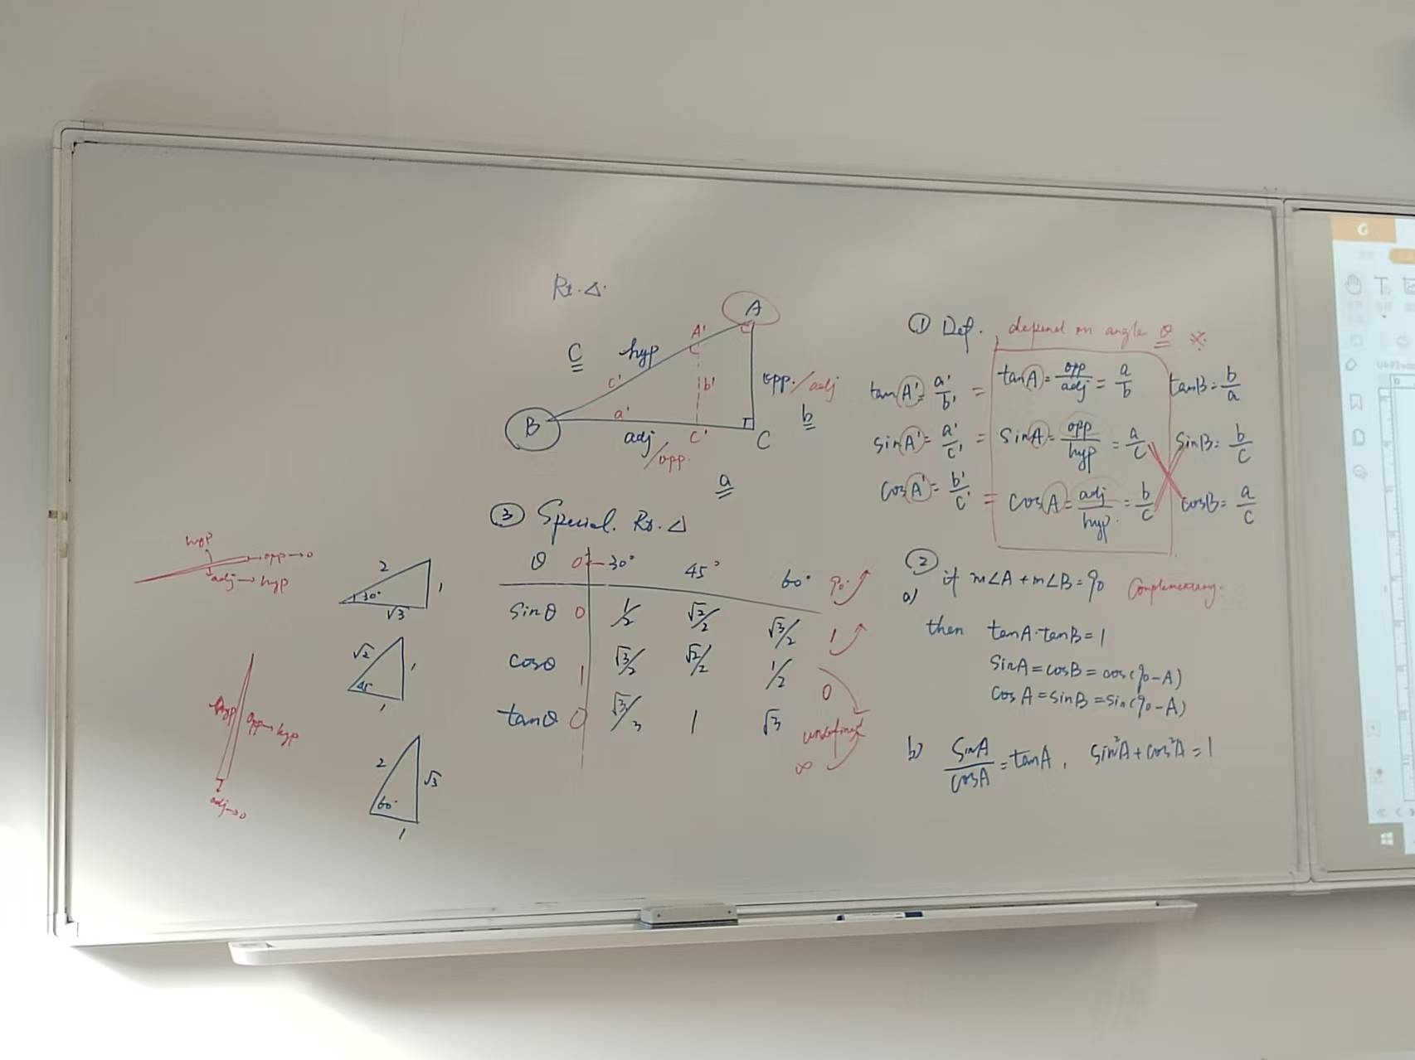

1. ***8-5 Angles of Elevation and Depression***
2. **New terms**

**·Angle of Elevation**

**The angle of elevation is the angle above the horizontal when looking up at an object.**

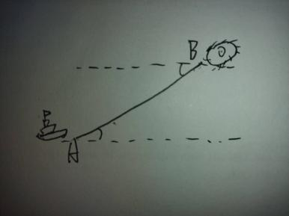**Just the angle A on the right picture.**

**·Angle of Depression**

**The angle of depression is the angle below the horizontal when looking down at an object. Just the angle B on the right picture.**

1. **Solving right triangle**

**sinX/1=opposite/hypotenuse**

**cosX/1=adjacent/hypotenuse**

**tanX/1 = sinX/cosX = opposite/adjacent**

**H(eight)=bsinA=asinB**

**A(rea) of triangle=1/2base height=1/2 ab sinC=1/2 ac sinB= 1/2 bc sinA**

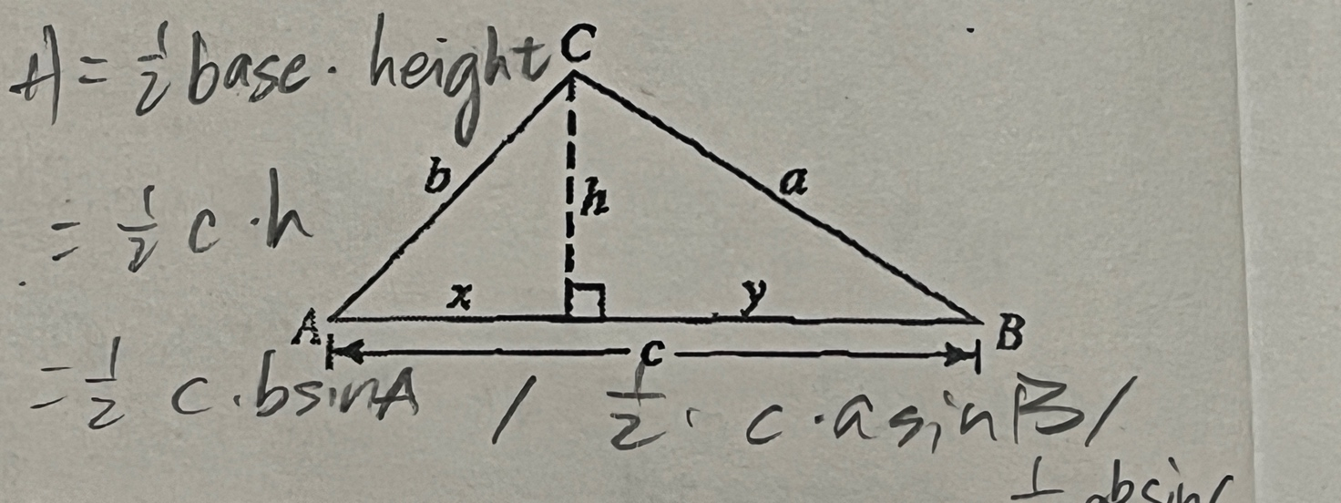

1. **Areas of parallelograms and triangles**

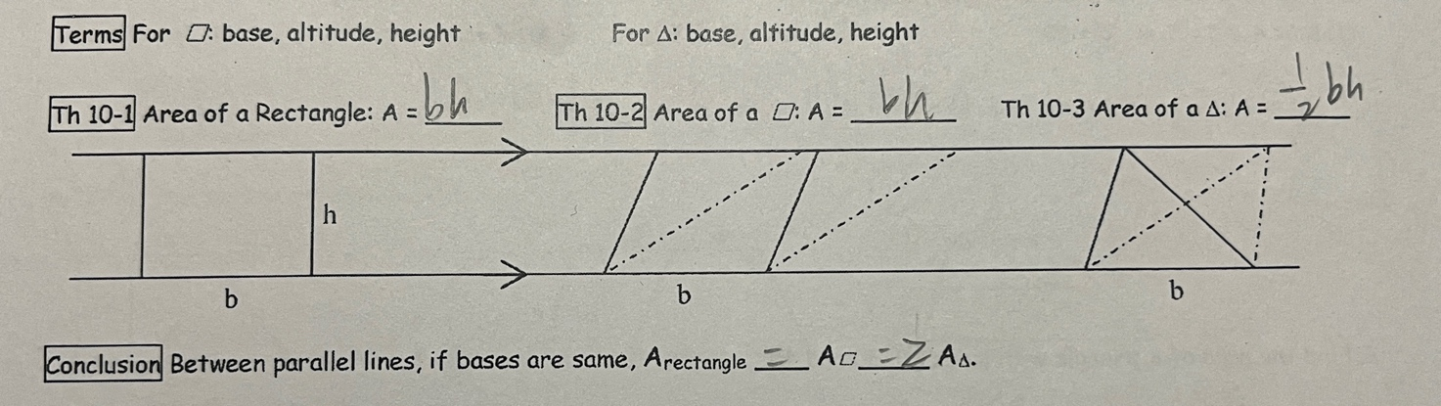

**A(rea) of a rectangle = B(ase) H(eight)**

**Heron’s formula: S(ide): 1/2 (a+b+c)**

## A(era): √(s-a) (s-b) (s-c)

## (根号)

1. **Areas of trapezoids, rhombuses, and kites**

**Areas of trapezoids: 1/2 (base1+base2) height**

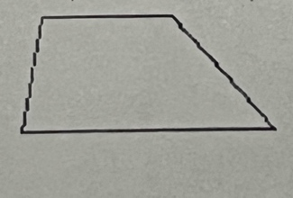

**Areas of rhombuses, and kites: 1/2 base1 base2**

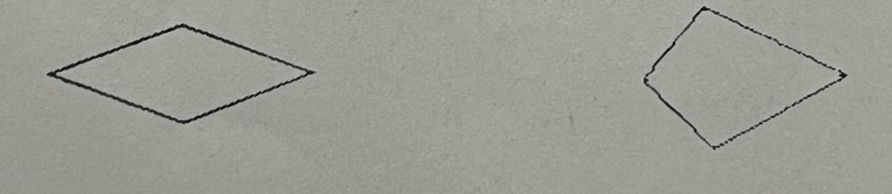

1. **Areas of regular polygons**

Area of a regular n-gon: n(1/2 side apothem)=1/2ap

Area: √3/4

**A:(1/2 sinX)n**

**A: 1/2 n sinX**

**(x= 360/n)**